Emily Frazin

Overview

This application is a way to organize the runnings of a dance studio.  Everything is available online for the owner, instructors, and students. Having everything available online gets rid of the paper trail of registration forms, newsletters, events/performance letters, and also makes payment of tuition easier. Dancers can create a profile that keeps track of payments and their class schedules, so they won’t forget those important details.

I believe that this application will cut out the stress of keeping track of all the students at a studio, because everything is on the site.

Design Layout

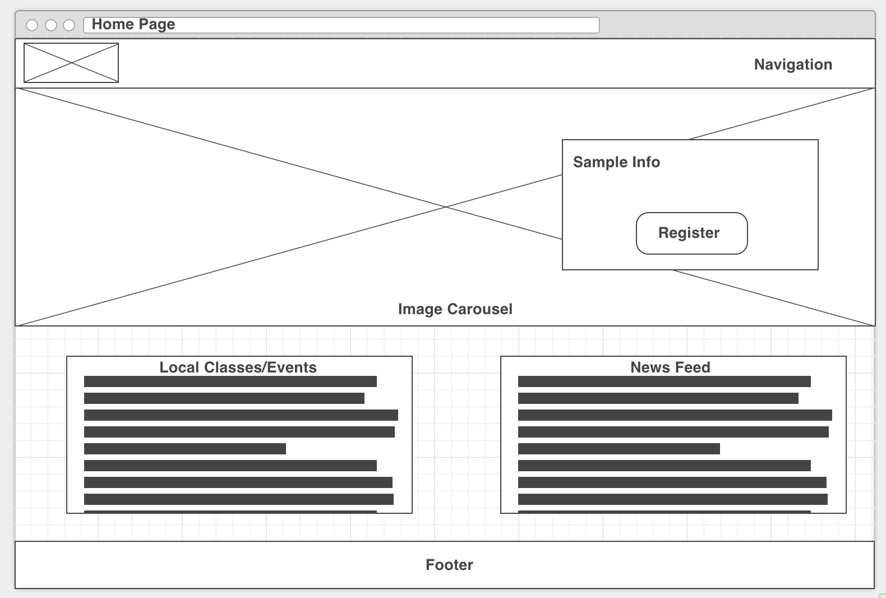

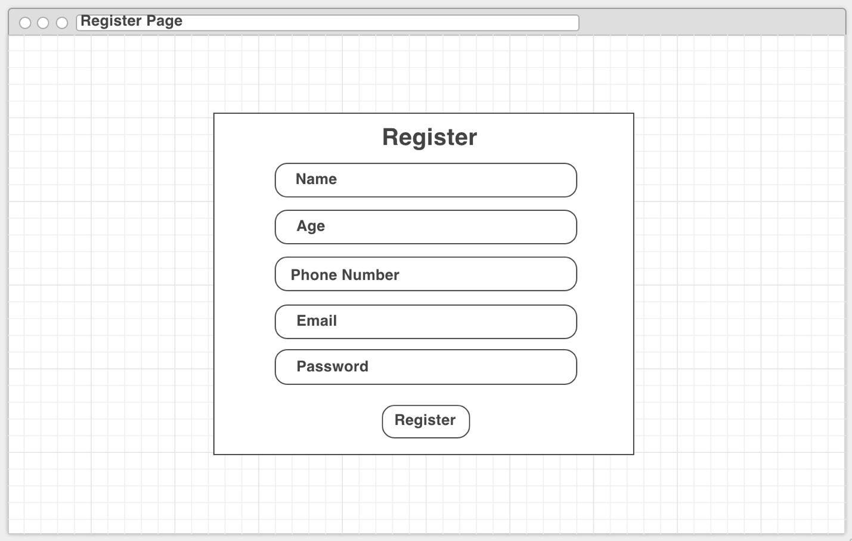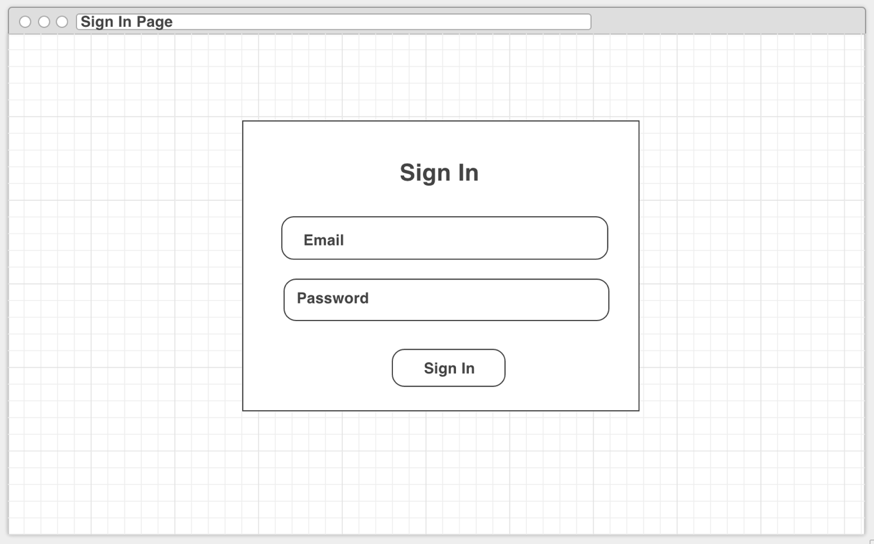

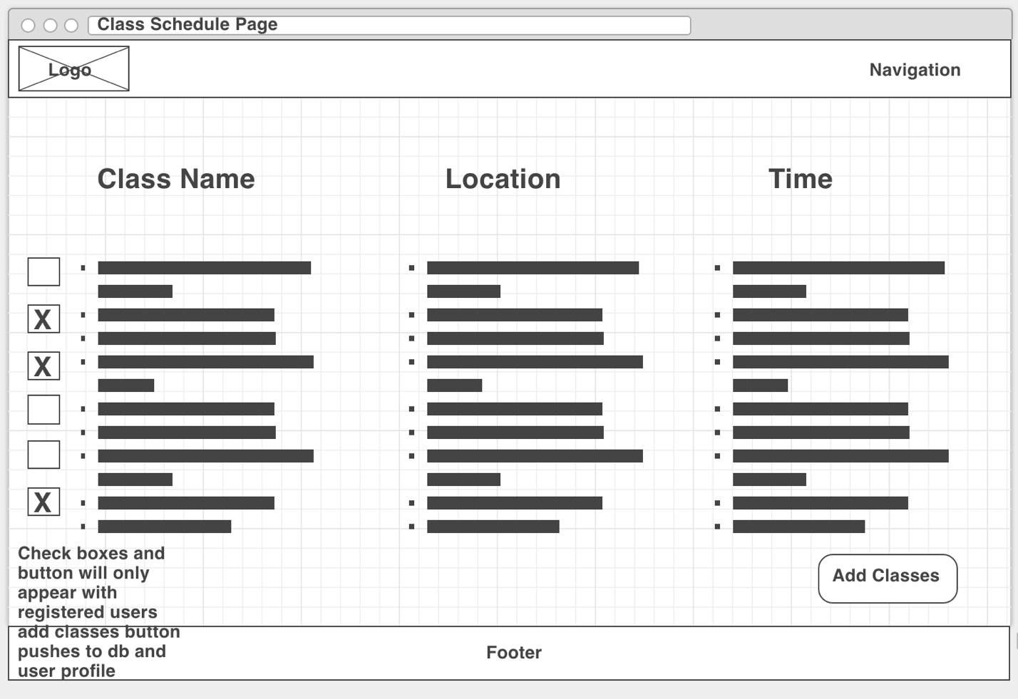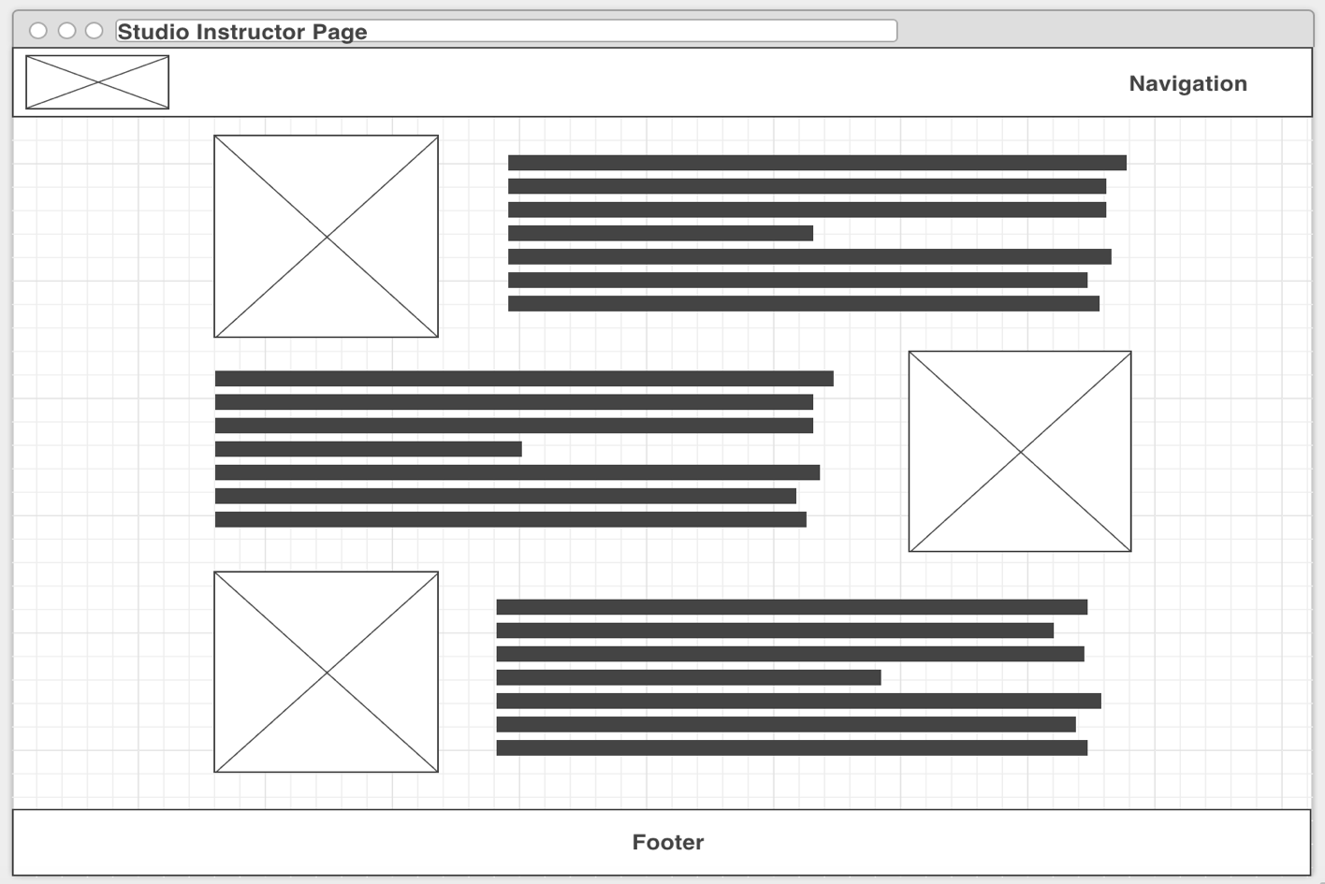

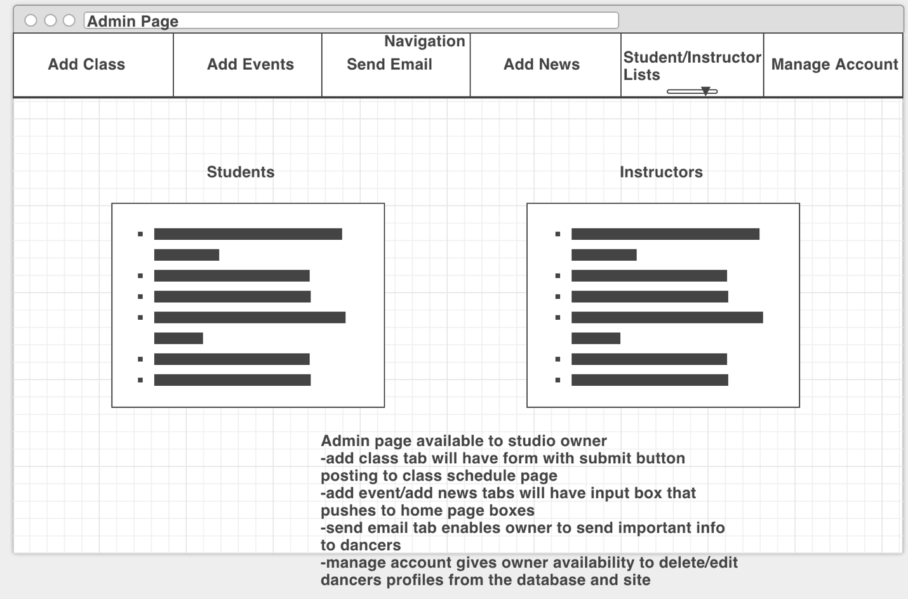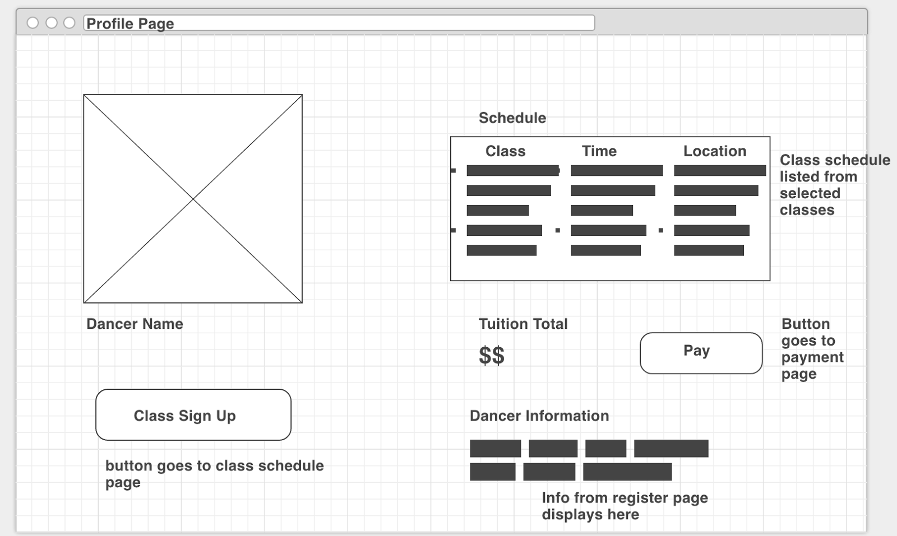

Trello Board

